|  |  |
| --- | --- |
|  | **Requirements Document** |

Care Management Operational Dashboard

Date: 04/05/2021

Current Version: 0.17

Author: Aditi Bhagat

Contents

1 Document History 3

1.1 Project Information 3

1.2. Revision History: 3

2 Introduction 4

3 Systems and Users Affected 4

4 Assumptions and Constraints……………………………………………………………………………………………………………5

5 Metrics to be reported 5

6 Business Requirements – Care Management Operational Dashboard 6

7 Inclusion/Exclusion Criteria…...……………………………………………………….……………………………………………….8

8 Reference…….………………………………………………………………………………………………………………………………….9

# Document History

## 1.1 Project Information

|  |  |
| --- | --- |
| Project Name: | Care Management Operational Dashboard |
| Requesting Division: | CHOICE BI and Analytics |
| Project Sponsor: |  |
| Project Manager: | Ipsita Sahu |
| Sr. Business Analyst: | Aditi Bhagat |
| Business stakeholders | June Stanley, Esther Conteh, Sherri McPherson, Grace McGhee, AnneMarie Manzi |

## 1.2. Revision History:

|  |  |  |  |
| --- | --- | --- | --- |
| **Version** | **Description of Change** | **Revision Date** | **Modified By** |
| 0.1 | Initial Draft | 3/11/2020 | Aditi Bhagat |
| 0.2 | Updated the document with details for the following metrics:   * PCSP on Enrollment * PCSP on Reassessment | 3/24/2020 | Aditi Bhagat |
| 0.3 | Updated section 4: Assumptions and Constraints, number ‘5’. | 3/30/2020 | Aditi Bhagat |
| 0.4 | Updated section 4: Assumptions and Constraints, number ‘5’   * Aging report will display data cuts for the current month, prior month and prior two months. * Added the thresholds/target for the metric. | 4/15/2020 | Aditi Bhagat |
| 0.5 | Phase 2:  Based on the meeting with Esther and team on 4/22/2020, updated the document with the details for the following metrics:   * Back Up Care Plan * Advanced Directives * MD Collaborator on file * MD f/u Appointment | 4/24/2020 | Aditi Bhagat |
| 0.6 | Based on the inputs from Esther, updated the drill down details to be captured for the ‘Not Completed’ category for the two metrics below:   1. PCSP on Enrollment 2. PCSP on Reassessment | 4/30/2020 | Aditi Bhagat |
| 0.7 | **Phase 3:**  Added the ‘**COVID- 19 Choice Script’** as a qualifying script for the ‘Completed’ category for the Monthly Contact Metric. | 5/5/2020 | Aditi Bhagat |
| 0.8 | Based on the discussion with Esther and Patrina, updated the following:   * Revised the reporting criteria (numerator and denominator) for the biannual and annual metrics (Back-Up Care Plan, Advanced Directives and MD f/u appointment).   Note: We will not capture the history for the member once the member disenrolls from the plan.   * Add member level details for the ‘Completed’ category in addition to the ‘Not Completed’ category for the Back-Up Care Plan and Advanced Directive for the CM team to get a detailed picture on which members have completed the respective metrics, by LOB. | 5/20/2020 | Aditi Bhagat |
| 0.9 | Updated the logic for biannual and annual metrics as per the feedback from CM team:   * When a member has more than one Back-up Care Plan or Advanced Directives completed within the same month or the measurement period (Jan-June, Jul-Dec) – the dashboard must capture the latest activity performed based on the completion date within the measurement period for the member. This is applicable to both Summary page and the member details. Given that a case follows the person who it is assigned to, the CM team want to see the latest information on the metric completion and which CM/CCM it is assigned to. Both these metrics will run biannually and at the end of each measurement period, the completion rate is based on the latest activity (the various instances/options accounted for completion of these metrics are not applicable here). * For both biannual metrics (BCP and AD) and the annual metric (MD F/u appointment) the dashboard must capture the latest script completed for the CM team to monitor the metric performance for the given measurement period. * When a member switches delegated vendors during the measurement period, the metric completion is attached at the member level. The biannual metric does not have to be entered again for the same period if completed by 1 vendor. | 06/10/2020 | Aditi Bhagat |
| 0.10 | Updated the criteria for capturing the MD Collaborator on file-  Members in the ‘Completed’ category should have drill-down details on:   * MD Collaborator on file for the member with the name, created on date, updated on date. (drop the start date, end date). * The latest MD Collaborator must be captured based on the ‘Updated On’ date. For cases where the ‘Updated On’ date is missing, we capture the latest ‘Created On’ date. | 6/17/2020 | Aditi Bhagat |
| 0.11 | 1) Updated the document with the details for the following metrics:   * HRA Completion on Enrollment * HRA Completion – Annually * Influenza Vaccine Update   2)As per the discussion with Esther on 6/25/2020, ‘CBLTC Services in Place’ metric is determined to be **Out of Scope**. | 6/30/2020 | Aditi Bhagat |
| 0.12 | Enhancement requested for the two PCSP completion metrics updated in the criteria for below metrics as discussed with Esther on 11/17/2020:   1. PCSP on Enrollment 2. PCSP on Reassessment | 11/18/2020 | Aditi Bhagat |
| 0.13 | 1. Updated the Scripts and Activity Type to be included for the ‘Completed’ category for the Monthly Contact metric. 2. Enhancements requests to be included on the Monthly Contact metric updated in the metric reporting methodology for the Monthly Contact Metric. 3. Updated the threshold details for the ageing column to be included in the member details for PCSP on Enrollment and PCSP on Reassessment metrics. 4. Updated the metric list with the newly identified metrics to be included on the dashboard (metrics 12 through 20). 5. Updated the document with details on the Welcome Call metric. | 2/1/2021 | Aditi Bhagat |
| 0.14 | 1. Updated the criteria for ‘Completed’ category for the Monthly Contact metric to include PPS Script (as of Feb 2021) for MAP LOB.  2. As Advised by Esther, updated the threshold for PCSP ageing component in the requirements for PCSP on Enrollment and Reassessment metrics.  3. Enhanced Welcome Call metric details to include the ageing component to capture if members received the Welcome call after 15 days on Enrollment. | 2/4/2021 | Aditi Bhagat |
| 0.15 | As advised by AnneMarie Manzi on 2/25/2021, updated the calculation criteria for the aging column for PCSP on Enrollment and PCSP on Reassessment.   * Aging column for PCSP on Enrollment = First day of the month should be counted as Day 1, completion date is the 15th day of the month. * Aging column for PCSP on Reassessment= Last UAS completion date should be counted as Day 1. | 2/25/2021 | Aditi Bhagat |
| 0.16 | As informed by CM team on 3/1/2021, updated the sequence of events for PCSP completion on enrollment and reassessment.  PSP completion does not impact PCSP to be completed (this criterion was revised mid-January 2021), PCSP must follow UAS assessment date. | 3/03/2021 | Aditi Bhagat |
| 0.17 | As discussed with the CM team on 3/29, updated the BRD as below:   1. To implement the design changes on the current dashboard for the **Monthly Contact metric,**  to capture the total number of contacts(all) made to the member during the month including successful attempt, unsuccessful attempt, not attempted the criteria for the numerator will be revised to account for contacts made via ***scripts only***. (Current version account for scripts, activity type and notes towards a member contact. There isn’t a way to systemically records unsuccessful attempts if the member contact is documented via activity type or notes). 2. The successful attempt, unsuccessful attempt and not attempted criteria is applicable to the **Welcome Call metric** as well, where up to 3 unsuccessful attempts are documented within the ‘**Welcome Call Final GCV8 script’** in Guiding Care**.** 3. Each individual script captures up to 3 unsuccessful attempts (i.e. where a contacted is attempted but the CM is unable to reach the member, each unsuccessful attempt is documented which will count towards the total contacts made to the member). For the total percentage completion on the summary page, only the ‘successful’ attempts will be captured. Sample screenshots for unsuccessful attempts documented in Guiding Care added to the reference section. 4. Added the list scripts that will be broken down from the Master Script (**beginning May 2021**). 5. Updated the CM Ops Dashboard Summary page with the footnote: “Biannual and Annual measures will refresh on the 3rd of the month”. | 04/05/2021 | Aditi Bhagat |

# Introduction

The Requirements Document is a formal document that provides insight into business requirements to be implemented for the Care Management Operational Dashboard.

* 1. **Overview:**

The purpose of this document is to make stakeholders aware of the reporting methodology for each of the metrics provided by Care Management team.

The business ask is to create a dashboard for Care Management team that provides the senior leadership with an overview for the various metrics for MLTC and MAP plans focused towards Care Management to meets their operational needs. This is to ensure that all the key operational metrics are monitored and measured against the defined targets and the senior leadership can identify the underlying cause for any metric that do not meet these defined targets Care Management team will be using this dashboard to determine if additional measures are needed to increase operational efficiency.

# Systems and Users Affected

***3.1 Users:***

* CHOICE BI & Analytics Department
* Care Management Team

***3.2 Systems:***

|  |  |  |  |  |  |  |  |  |  |  |  |  |  |  |  |  |  |  |  |  |  |  |  |  |  |  |  |  |  |  |  |  |  |  |  |  |  |  |  |  |  |  |  |  |  |  |  |  |  |  |  |  |  |  |  |  |  |  |  |  |  |  |  |  |  |  |  |  |  |  |  |  |  |  |  |  |  |  |  |  |  |  |  |  |  |  |  |  |  |  |  |  |  |  |  |  |  |  |  |  |  |  |  |  |  |  |  |  |  |  |  |  |  |  |  |  |  |  |  |  |  |  |  |  |  |  |  |  |  |  |  |  |  |  |  |  |
| --- | --- | --- | --- | --- | --- | --- | --- | --- | --- | --- | --- | --- | --- | --- | --- | --- | --- | --- | --- | --- | --- | --- | --- | --- | --- | --- | --- | --- | --- | --- | --- | --- | --- | --- | --- | --- | --- | --- | --- | --- | --- | --- | --- | --- | --- | --- | --- | --- | --- | --- | --- | --- | --- | --- | --- | --- | --- | --- | --- | --- | --- | --- | --- | --- | --- | --- | --- | --- | --- | --- | --- | --- | --- | --- | --- | --- | --- | --- | --- | --- | --- | --- | --- | --- | --- | --- | --- | --- | --- | --- | --- | --- | --- | --- | --- | --- | --- | --- | --- | --- | --- | --- | --- | --- | --- | --- | --- | --- | --- | --- | --- | --- | --- | --- | --- | --- | --- | --- | --- | --- | --- | --- | --- | --- | --- | --- | --- | --- | --- | --- | --- | --- | --- | --- | --- | --- |
| * Guiding Care * FACETS (member information)  Assumptions and Constraints  1. This will be a daily dashboard to include all the key metrics identified by Care Management team, to provide visibility to the Care Management leadership as well as the front-line staff (making this an interactive dashboard for the staff) on where we stand on each of these metrics daily, so they can proactively work towards meeting the targets for those measures. 2. The dashboard will display the Monthly and YTD data for MLTC and MA LOBs beginning April 2020 as required per metric. 3. The dashboard will report the data into two categories for each metric: ‘Completed’ and ‘Not Completed’. 4. The data for each “Completed’ and ‘Not Completed’ category will be drillable, so the CM team can dig deeper in to “Not completed” measures and focus on completing the targets for those cases. 5. The dashboard will also provide month over month trends and aging reports *applicable to the metrics.* 6. **Monthly Contact Metric**: For the ‘Not Completed’ members within the Monthly Contact metric, the dashboard will show how many were rolled over from the prior ***one month and prior two months.***   Note: Showing roll overs from “more than two” prior months will get complex and dicey, so the dashboard will show the roll overs every month for the “not completed” bucket from the “prior month” and “prior two months”. See example below to get more clarity:  **Example**: For April, say out of the **100 monthly calls due in April 80 got completed in April and 20 were Not completed in April.** Out of the 20 Not completed in April, the dashboard will show how many are being carried from a) March (meaning out of the 20 not completed in April, say 10 were also in the ‘Not completed’ bucket in March, the dashboard will capture this) b) February ( meaning out of the 20 not completed in April, say 10 were also in the ‘Not completed’ bucket in March, the dashboard will capture this AND say 5 were also in the ‘Not completed’ bucket in February, the dashboard will capture this - **basically ‘not contacted’ for three consecutive months).**   1. **For PCSP Assessment and PCSP Re assessment metrics**- since these two are 6-month period metrics driven by UAS assessments, **roll over from prior month is challenging. The dashboard will show only every month “Completed” and “Not completed” Buckets for these two metrics.** These metrics will be broken down by Care Managers and CCMs. 2. The dashboard will include LOB selector to see the specific performance between MLTC and MAP, since some of these metrics are pertinent to MAP only. 3. The dashboard will include Delegated Care Management Indicator to filter though Eddy, VNA, ICS, VNS. 4. “Auto enrolled members” are out of scope for PCSP metrics since Auto-enrolled members would not have PSP completed on enrollment, this would be a negligible count of members.   Future goal: Eventually this dashboard will be provided to the external delegated CM Vendors for them to monitor their performance for the metrics.   1. Operational thresholds/targets for the metrics are as below:  * Green: >90 % * Yellow: Between 81-90% * Red: < 80%   cid:image001.png@01D61254.DAED83C0   1. Disenrolled members will be excluded from the numerator for the bi-annual and annual metrics on the dashboard. 2. Credit for the metric completion is due to the current Care Manager attached to the case.   Example –   * Member ‘X’ is with Eddy from Jan-March 2020 and the BCP is completed for this member in March by Eddy’s Care Manager let’s say Jen. When looking at our dashboard, the summary page should count this member in the ‘completed’ bucket and in the member level details we should see that member ‘X’ had BCP completed in March by Eddy’s CM Jen (CM Jen gets credit for metric completion for this member till March). * Now let say this member moves to VNSNY in April 2020 and assigned to VNSNY’s Care Manager Rob. Starting April onwards when looking at our dashboard the summary page should still count this member in the ‘completed’ bucket and in the member level details we should see that member ‘X’ had BCP completed in March, but the credit for this metric completion now moves to Rob – the Care Manager for VNSNY who this member currently belongs to. (When looking at this from a CM perspective, the dashboard must show that Rob had completed BCP for this member for the current period). * At any given time, the business users want to see the current owner of the case as credit for the metric completion is due for the current Care Manager attached to the case, regardless of who completed the BCP/AD within the measurement period. Likewise, if the member is with Eddy let’s say from Jan-May 2020 and moves to VNSNY in June with BCP not completed; in this case the Care Manager from VNSNY will be accountable for completion of the BCP/AD for the member even though the member had been with Eddy for the prior five months of the measurement period.  1. In terms of security, the delegated vendors ***must not have access*** to membership of other vendors. Once the member disenrolls with a vendor they no longer are accountable how the member is served, or which metrics are completed for the member going forward.  Metrics to be displayed on the dashboard ***5.1 Metric List (Initial in scope from 2020)***   1. Monthly Contact 2. PCSP on Enrollment 3. PCSP on Reassessment 4. Back Up Care Plan 5. Advanced Directives 6. MD Collaborator on file 7. MD F/u appointment 8. HRA Completion on Enrollment 9. HRA Completion – Annually 10. Influenza Vaccine Update 11. CBLTC Service in place   Newly identified metrics for the dashboard:   1. Welcome Call 2. Timely Disenrollment 3. Monthly Facility Discharge 4. Service Interruption 5. Monthly Assessment Call Reason 6. TOC 7. RA 8. PPS Completion on Enrollment 9. PPS Completion   ***5.2 Metric Details***   |  |  |  |  | | --- | --- | --- | --- | | **Serial #** | **Metric** | **Metric Frequency/Expected Completion Target** | **LOBs to be reported for** | | 1 | Monthly Contact | Monthly | MLTC, MAP | | 2 | PCSP on Enrollment | 15 days from Enrollment | MLTC, MAP | | 3 | PCSP on Reassessment | 15 days from Reassessment | MLTC, MAP | | 4 | Back Up Care Plan | Biannually (Jan-June and Jul-Dec) | MLTC, MAP | | 5 | Advanced Directives | Biannually (Jan-June and Jul-Dec) | MLTC, MAP | | 6 | MD Collaborator on file | Monthly | MLTC, MAP | | 7 | MD f/u Appointment | Annually (Jan-Dec) | MLTC, MAP | | 8 | HRA Completion on Enrollment | 90 days from Enrollment | MAP only | | 9 | HRA Completion | Annually | MAP only | | 10 | Influenza Vaccine Update | Monthly | MLTC, MAP | | 11 | CBLTC Services in Place **(Out of Scope)** | Monthly | MLTC, MAP | | 12 | Welcome Call | Monthly | MLTC, MAP | | 13 | Timely Disenrollment | TBD | TBD | | 14 | Monthly Facility Discharge | TBD | TBD | | 15 | Service Interruption | TBD | TBD | | 16 | Monthly Assessment Call Reason | TBD | TBD | | 17 | TOC | Monthly | MLTC, MAP | | 18 | RA | Monthly | MLTC, MAP | | 19 | PPS Completion on Enrollment | 90 days from enrollment (new enrollees only) | MAP | | 20 | PPS Completion | Annually | MAP |  1. ***Metric reporting methodology***  |  |  |  |  | | --- | --- | --- | --- | | **#** | **Metric** | **Metric Definition** | **Criteria for ‘Completed’ Category** | | 1 | Monthly Contact | This metric is used to monitor the proportion of active members who receive a minimum of one successful telephonic care management contact per month. | Denominator: Active Census (total count of active members for the month)  **[A] MLTC and MAP**  ‘Completed’ Contacts (Scripts, Activities, Notes)  Scripts:   1. Master Scripts   The list scripts that will be broken down from the Master Script (**beginning May 2021**):   * CM - Cerebral Vascular Disease 2 * CM - Urinary Tract Infection * CM – Sepsis * CM – Hypertension * CM - Heart Failure * CM - Fall Prevention * CM – Diabetes * CM - Cognitive Impairments * CM – Anemia * CM - Pain Management 2 * CM - Cancer Management * CM - Coronary Artery Disease2 * CM - Social Determinants of Health_CT * CM - Skilled Nursing Facility * CM - Respiratory Infection * CM – Psychosocial * CM - Osteoarthritis Management * CM - Neurological Disorder  1. Welcome Call Final GCV8 2. Transition of Care Final GCV8 3. Reassessment Final GCV8 4. COVID- 19 Choice Script – beginning **May 2020** 5. HRA Script (MAP only) 6. Advanced Illness Assessment PPS V3 (PPS Script as of **Feb 2021**, MAP only)   Activities Type: (**Out of Scope)**   1. Care Coordination 2. Care Transitions 3. TCM: Care Planning 4. TCM: Care Coordination 5. TCM: Care Transitions 6. TCM: Disenrollment Planning  * ICT/IDT Case Conference (MAP only) * Wellness Initiatives (MAP only) * MEC- Medicaid Issues (MAP only)   Notes: (**Out of Scope)**   1. TCM: PCSP/ CARE PLANNING 2. IDT/ICT Note (FIDA specific) 3. TCM: General 4. TCM: Member Call 5. TCM: Caregiver/ Family Support 6. End Of life Care Planning Consult  * MEC Medicaid Issues (MAP only)   If the above Scripts, Activities, Notes are not found in GC for the member, then they fall under “Not completed” category for MLTC  The Scripts, Activity Type and Notes are applicable to both MLTC and MAP LOBs.  **Ageing Component logic**:  1. If member is not contact during the current month, they would be included for the 'selected month' member count.  2. If member is not contact for this month and previous month, they would be included for the 'prior month' member count (not contacted for past 60 days).  3. If member is not contacted this month and previous 2 months, they would be included for the 'prior two months' member count (not contacted for past 90 days).  **Enhancement requested** –   1. ~~Care type details (stating if the member contact was documented via the Script/Activity Type/Notes) attributing towards the monthly contact to be included for the ‘completed’ bucket in metric details.~~ 2. Care Type description (Script/ ~~Activity Type/Notes~~) to be included for the ‘completed’ bucket in metric details. 3. Slice the data further for the existing two buckets (Completed and Not Completed).  * For members who we successfully contacted, how many total contacts did the Care Manager make during the month (total cunt). When a member is contacted 1+ times during the month, the member details would display the latest contact/activity date. (Dashboard must capture total number of attempts and latest contact with the activity date (labeled as ‘measure completed date’ on the dashboard) for the month). * For members who were not contacted during the month, capture the contact attempts made by the Care Manager prior to closing the script (three unsuccessful contacts tracked for compliance; dashboard must capture all attempts with the date activity occurred).   **Design changes to be implemented as decided on 3/29/2021**–   1. To implement the design changes on the current dashboard for the Monthly Contact metric,  to capture the total number of contacts(all) made to the member during the month including successful attempt, unsuccessful attempt, not attempted the criteria for the numerator will be revised to account for contacts made via ***scripts only***. (Current version account for scripts, activity type and notes towards a member contact. There isn’t a way to systemically records unsuccessful attempts if the member contact is documented via activity type or notes.   ***See screenshots attached in the reference section for unsuccessful attempts documented in Guiding Care (1).***  **Please note**: The percentage for successful attempts may be lower as the activity type and notes will not be accounted towards the numerator hit going forward, the new criteria will be as per the Compliance Dashboard.   1. Each individual script captures up to 3 unsuccessful attempts (i.e. where a contacted is attempted but the CM is unable to reach the member, each unsuccessful attempt is documented which will count towards the total contacts made to the member). For the total percentage completion on the summary page, only the ‘successful’ attempts will be captured. No further notes/description/comments are added in Guiding Care when an unsuccessful attempt is documented in a script by a Care Manager. | | 2 | PCSP on Enrollment | This metric is used to monitor the proportion of newly enrolled members who receive PCSP (for approved PSPs). | Denominator: New enrollees in each month (1st of every month)  Numerator for “Completed” Category: Newly enrolled members in a given month with the completed document/script “**Person-Centered Service Plan**” in Guiding Care (i.e. the status must be completed, not pending). *See screenshot in the reference section.  Numerator for “Not Completed” Category:  Newly enrolled members in each month with the document/script “**Person-Centered Service Plan**” Not saved/ not found in Guiding Care (Document status not completed in GC). *See screenshot in the reference section.  Members in the “Completed’ and ‘Not Completed’ category should have drill-down details on:   1. Latest UAS assessment date for the enrolled member. 2. Latest PSP completion date for these members (**script in GC is called ‘PSP-NEW’**).   **Enhancement** –   1. Completed category member details to include PCSP completion date (labeled as ‘Activity date’ on the dashboard). 2. In drill down details, column reordering should be in this sequence: 3. Member Enrollment date 4. Last UAS Completion date 5. PSP Completion date 6. PCSP Completion date (Activity Date) for ‘Completed’ category only. Note: History is not retained for PCSP completion dates, once a PCSP is completed for the member, it will be captured within the ‘completed’ bucket. 7. **Aging column for PCSP on Enrollment-** Day of Enrollment is Day 1 for aging to begin.  * PCSP on Enrollment, first day of the month should be counted as Day 1, completion date is the 15th day of the month.   *Aging column for ‘**Completed**’ and ‘**Not Completed’** category*  The aging column should display # of days to complete PCSP.   * Presentation threshold for red, yellow, green.   **Note**: Driver date is the 1st of every month for newly enrolled member.  Threshold details are as below:   * Green = Day 1 to day 10 (members are within the compliance window for PCSP completion) * Yellow = Day 11 to day 15 (members are within the compliance window but nearing expected PCSP completion date) * Red = Day 16 and beyond (members out of compliance for expected PCSP completion date) * When a member if enrolled on 1st of the month and PCSP is completed on the 20th of the month, in this example the aging column should display 20 days (in red) within the ‘Completed’ category. This is for the CM team to identify that PCSP was completed 20 days after enrollment and not in the expected 15-day window of completion (aging count starts from the start of enrollment). * For a member enrolled on November 1, when **PSP** is not completed till Nov 6th (as an example) then the aging column must display 6, regardless if PSP is completed or not completed.   **Graphs** to be included on the dashboard for PCSP metrics:   1. UAS Completed, but PSP “Not completed” 2. UAS Completed and PSP Completed, but PCSP “Not completed”   **Note: As per the defined business process, the sequence of events is: When UAS is completed, ~~PSP gets completed~~ and only then PCSP can start. (updated on 3/3/2021). *PCSP must follow the UAS assessment date.*** | | 3 | PCSP on Reassessment | This metric is used to monitor the proportion of members who receive PCSP on reassessment (for approved PSPs). | Denominator: Active members eligible of reassessment (based on the previous assessment date).  Numerator for “Completed” Category: Active members, eligible for reassessment with the completed script “**Person-Centered Service Plan**” in Guiding Care (i.e. the status completed, not pending).  *See screenshot in the reference section.  Numerator for “Not Completed” Category:  Active members, eligible for reassessment with the script “**Person-Centered Service Plan**” Not completed (saved) in Guiding Care (the status other than completed).  Members in the ‘Completed’ and ‘Not Completed’ should have drill-down details on:   1. Latest UAS assessment date for the member. 2. Latest PSP completion date for these members (**script in GC is called ‘PSP-NEW’**).   **Enhancement -**   1. Completed category member details to include PCSP completion date (labeled as ‘Activity date’ on the dashboard). 2. In drill down details, Column reordering should be in this sequence: 3. Member Enrollment date 4. Last UAS Completion date 5. PSP Completion date 6. PCSP Completion date (Activity Date) for ‘Completed’ category only. Note: History is not retained for PCSP completion dates, once a PCSP is completed for the member, it will be captured within the ‘completed’ bucket. 7. **Aging column for PCSP on Reassessment** Last day of UAS assessment is Day 1 for aging to begin.  * PCSP on Reassessment, date of last UAS assessment should be counted as Day 1.   *Aging column for ‘**Completed**’ and ‘**Not Completed’** category*  The aging column should display # of days to complete PCSP.   * Presentation threshold for red, yellow, green.   **Note**: Driver date is the last UAS completion date for the member.  Threshold details are as below:   * Green = Day 1 to day 10 (members are within the compliance window for PCSP completion on Reassessment) * Yellow = Day 11 to day 15 (members are within the compliance window but nearing expected PCSP completion date for reassessment) * Red = Day 16 and beyond (members out of compliance for expected PCSP completion date on reassessment) * When a last UAS date for a member is 5th of the month and the PCSP on reassessment is completed on the 25th of the month, in this example the ageing column should display 20 days (in red) within the ‘completed’ category. This is for the CM team to identify that PCSP was completed 20 days after last UAS completion and not in the expected 15-day window of completion. * For a member with last UAS date on November 5th, when **PSP** is not completed till Nov 12th (as an example) then the aging column must display 7, regardless is PSP is completed or not completed.   **Graphs** to be included on the dashboard for PCSP metrics:   1. UAS Completed, but PSP “Not completed” 2. UAS Completed and PSP Completed, but PCSP “Not completed”   **Note: As per the defined business process, the sequence of events is: When UAS is completed, ~~PSP gets completed~~ and only then PCSP can start. (updated on 3/3/2021). *PCSP must follow the UAS assessment date.*** | | 4 | Back Up Care Plan | This metric is used to monitor the proportion of active members for whom the Back Up Care Plan has been completed and documented in Guiding Care. | **MLTC and MAP:**  Denominator: Active Census (total count of active members for the month)  **Note**: Disenrolled members will be excluded from the numerator.  e.g.: If a member is active in April 2020, has completed Back-Up Care Plan in April 2020 and disenrolls in May 2020, this member will not be a part of our reporting i.e. it will be excluded in the denominator and the numerator for the entire period (beginning Jan 2020). When looking at the drill down for member level details, we drop this disenrolled member even if the back-up care plan was completed in April 2020. Alternatively, if this member disenrolls in August 2020(during Period 2) we drop this disenrolled member, even if the back-up care plan was completed in Period 1.  **We will not capture the history for the member once the member disenrolls from the plan.**  Numerator for “Completed” Category: Active members for whom the Back Up Care Plan has been completed and documented in Guiding Care. (i.e. for the parameter ‘Back-up Care Plan’ within the Health Indicator Section in Guiding Care, the **parameter value = ‘TRUE’** to be marked complete)  *See screenshot in the reference section.  Numerator for “Not Completed” Category:  Active members for whom the Back Up Care Plan has not yet been completed and documented in Guiding Care. (i.e. for the parameter ‘Back-up Care Plan’ within the Health Indicator Section in Guiding Care, the **parameter value = ‘FALSE’** to be marked not complete)  **Note:** Since this is a biannual metric, we should see spikes in the ‘Completed’ bucket towards the end of each defined period i.e. January – June and July-December.  When a member has more than one Back-up Care Plan completed within the same month or the measurement period (Jan-June, Jul-Dec) – the dashboard must capture the latest activity performed based on the completion date within the measurement period for the member. This is applicable to both Summary page and the member details.  When a member switches delegated vendors during the measurement period, the metric completion is attached at the member level. The biannual metric does not have to be entered again for the same period if completed by 1 vendor.  **Add **member level details** for the ‘Completed’ category and ‘Not Completed’ category for this metric. | | 5 | Advanced Directives | This metric is used to monitor the proportion of active members for whom the Advanced Directives has been completed and documented in Guiding Care. | **MLTC and MAP:**  Denominator: Active Census (total count of active members for the month)  **Note**: Disenrolled members will be excluded from the numerator.  e.g.: If a member is active in April 2020, has completed Advanced Directives in April 2020 and disenrolls in May 2020, this member will not be a part of our reporting i.e. it will be excluded in the denominator and the numerator for the entire period (beginning Jan 2020). When looking at the drill down for member level details, we drop this disenrolled member even if the Advanced Directive was completed in April 2020. Alternatively, if this member disenrolls in August 2020(during Period 2) we drop this disenrolled member, even if the back-up care plan was completed in Period 1.  **We will not capture the history for the member once the member disenrolls from the plan.**  Numerator for “Completed” Category: Active members for whom the Advanced Directives has been completed and documented in Guiding Care. (i.e. the ‘**Addressed Date’ field** within the Advanced Directive Section of Care Plan tab in Guiding Care **must have a date value** to be marked complete).  *See screenshot in the reference section.  Numerator for “Not Completed” Category:  Active members for whom the Advanced Directives has not yet been completed and documented in Guiding Care. (i.e. the ‘**Addressed Date’ field** within the Advanced Directive Section of Care Plan tab in Guiding Care **must be null/ no value** to be marked not complete).  **Note:** Since this is a biannual metric, we should see spikes in the ‘Completed’ bucket towards the end of each period i.e. January – June and July-December.  When a member has more than one Advanced Directives completed within the same month or the measurement period (Jan-June, Jul-Dec) – the dashboard must capture the latest activity performed based on the completion date within the measurement period for the member. This is applicable to both Summary page and the member details.  When a member switches delegated vendors during the measurement period, the metric completion is attached at the member level. The biannual metric does not have to be entered again for the same period if completed by 1 vendor.  **Add **member level details** for the ‘Completed’ category and ‘Not Completed’ category for this metric. | | 6 | MD Collaborator on file | This metric is used to monitor the proportion of active members who have an associated MD Collaborator on file per month. | **MLTC and MAP:**  Denominator: Active Census (total count of active members for the month)  Numerator for “Completed” Category: Active members who have an associated MD Collaborator on file. (i.e. for the **Care Giver Type = Secondary** and **Role/Type = MD Collaborator**, the name of the physician/MD Collaborator **must be present** to be marked complete)  *See screenshot in the reference section.  Numerator for “Not Completed” Category:  Active members who do not have an associated MD Collaborator on file. (i.e. for the **Care Giver Type = Secondary** and **Role/Type = MD Collaborator**, the name of the physician/MD Collaborator **must be NULL/not present** to be marked not complete).  Members in the ‘Completed’ category should have **drill-down details on**:   1. MD Collaborator on file for the member with the name, ~~start date, end date,~~ created on date, updated on date. 2. In case of multiple MD Collaborators found for the member, the details section must capture the **latest MD Collaborator on file** based on the ~~start date~~ ‘Updated on’ date~~.~~ (see screenshot in the reference section).   For cases where the ‘Updated On’ date is missing, we capture the latest ‘Created On’ date. | | 7 | MD f/u Appointment | This metric is used to monitor the proportion of active members who have had a MD follow-up appointment once a year. | **MLTC and MAP:**  Denominator: Active Census (total count of active members for the month)  **Note**: Disenrolled members will be excluded from the numerator.  e.g.: If a member is active in April 2020, has completed MD f/u appointment in April 2020 and disenrolls in May 2020, this member will not be a part of our reporting i.e. it will be excluded in the denominator and the numerator for the entire period (beginning Jan 2020). When looking at the drill down for member level details, we drop this disenrolled member even if the MD f/u appointment was completed in April 2020.  **We will not capture the history for the member once the member disenrolls from the plan.**  Numerator for “Completed” Category: Active members who completed a MD Follow-up appointment for the given year (i.e. for the metric to be marked completed, the **status must be ‘Completed**’, with the **appointment date of the current year,** status must not be ‘Scheduled’ or ‘Cancelled’ within the Health tab, Appointments section in Guiding Care.  *See screenshot in the reference section.  When a member has more than one appointment within a month/measurement year, capture the latest instance both at the summary and member detail level.  Numerator for “Not Completed” Category:  Active members who have not completed a MD follow-up appointment for the year (i.e. for the metric to be marked not completed, the **status must be anything other than ‘Completed’** – within the Health tab, Appointments section in Guiding Care (Status may be ‘Scheduled’ or ‘Cancelled’ or blank with no status).  ***Note***: If the appointment status is seen as ‘complete’ but the appointment date is from the year 2019, this would fall in the ‘not completed’ category- meaning the MD f/u appointment is still due for the year 2020 for the member. | | 8 | HRA Completion on Enrollment | This metric is used to monitor the proportion of active members who have completed the Health Risk Assessment (HRA)within 90 days of enrollment. | ***Note: This metric is applicable for MAP only.***  Denominator: New enrollees in a given month (1st of every month).  **Note**: Disenrolled members will be excluded from the numerator.  e.g.: If a member is active in April 2020, has completed HRA in April 2020 and disenrolls in May 2020, this member will not be a part of our reporting i.e. it will be excluded in the denominator and the numerator. When looking at the drill down for member level details, we drop this disenrolled member even if the HRA was completed in April 2020.  **We will not capture the history for the member once the member disenrolls from the plan.**  Numerator for “Completed” Category: Newly enrolled members in a given month with the script ‘**HRA Script’** and Status = ‘**Completed**’ in Guiding Care within 90 days of enrollment (i.e. the status must be completed, not pending). *See screenshot in the reference section.  e.g.- If a member is enrolled on Sept 1st, 2020, the HRA on enrollment must be completed by Nov 30th, 2020.  Numerator for “Not Completed” Category:  Newly enrolled members in a given month with the script “**HRA Script**” and Status = ‘Not Completed’ or ‘blank’ in Guiding Care within 90 days of enrollment.  e.g.- If a member is enrolled on Sept 1st, 2020, the HRA on enrollment is completed after Nov 30th,2020 would fall into the ‘not completed’ category.  Members in the ‘Completed’ and ‘Not Completed’ category should have drill-down details on:   * Latest HRA performed date for the enrolled member.   **Note:** ***Initial HRAs conducted prior to the effective enrollment date are counted as initial HRAs in the year in which the effective enrollment date falls.*** For example, an initial HRA performed on November 23, 2019 for an enrollee with an effective date of enrollment of January 1, 2020 would be counted as an initial HRA in 2020. | | 9 | HRA Completion - Annually | This metric is used to monitor the proportion of active members who have completed the Health Risk Assessment (HRA) within 365 days of the last HRA on file. | ***Note: This metric is applicable for MAP only.***  Denominator: Active members eligible for annual HRA completion (within 365 days of the last HRA date).  **Note**: Disenrolled members will be excluded from the numerator.  e.g.: When a member is active and has completed HRA in April 2019 and is due for annual HRA in April 2020, if this member disenrolls in March 2020 than this member will not be a part of our reporting. i.e. it will be excluded in the denominator and the numerator. When looking at the drill down for member level details, we drop this disenrolled member even if the annual HRA is due in April 2020.  **We will not capture the history for the member once the member disenrolls from the plan.**  Numerator for “Completed” Category: Active members, eligible for annual HRA and with the script ‘**HRA script’** and Status = ‘**Completed**’ in Guiding Care and the ‘**Performed Date’** is within 365 days of last HRA performed date for the member. *See screenshot in the reference section.  e.g.- If a member has the last HRA completed on 6/15/2019, the next HRA is due within 365 days by 6/15/2020 to be ‘complete’.  Numerator for “Not Completed” Category: Active members, eligible for annual HRA and with the script ‘**HRA script’** and Status = ‘**Completed**’ in Guiding Care and the ‘**Performed Date’** is after 365 days of last HRA performed date for the member. *See screenshot in the reference section.  e.g.- If a member has the last HRA completed on 6/15/2020, the next HRA is due within 365 days, by 6/15/2021. If the HRA date is after 6/15/2020, this annual HRA would be counted as ‘not complete’.  Members in the ‘Completed’ and ‘Not Completed’ category should have drill-down details on:   * Latest HRA performed date for the member.   **Note:** ***A new enrollee who receives an HRA within 90 days of enrollment is due to complete a reassessment HRA no more than 365 days after the initial HRA was completed.***  ***All annual reassessment HRAs are due to occur within 365 days of the last HRA. Thus, when an initial HRA is performed in the 90 days prior to an effective enrollment date that member must complete the annual HRA with 365 days of initial HRA.*** | | 10 | Influenza Vaccine Update | This metric is used to monitor the proportion of active members who have been vaccinated for influenza within the influenza period (September through March). | **MLTC and MAP:**  Denominator: Active Census (total count of active members)  Numerator for “Completed” Category: Active members who have been educated on the influenza vaccine and ***have*** or ***have not*** been vaccinated during the influenza period which is between September to March. (i.e.   * **Parameter = Influenza** and **Value =True** (member got vaccinated) **OR Value =False** (member refused vaccination /did not get vaccinated) **AND Record Date** must be that of anytime between September through March influenza period).   *See screenshot in the **reference section.**  Numerator for “Not Completed” Category:  Active members who have the record date for the influenza parameter outside of the influenza period which is between September to March.   * **Parameter = Influenza** and the **Record Date** is before or after theinfluenza period of September through March (The value = True/False is not applicable for the ‘not completed’ category’).   Members in the ‘Completed’ and ‘Not Completed’ category should have **drill-down details on**:   1. Latest **Record Date** for the parameter of influenza vaccine where value = true/false. | | 11 | CBLTC service in place | TBD | **Out of Scope** | | 12 | Welcome Call | This metric is used to monitor the proportion of newly enrolled members who receive a Welcome Call within the first 15 days on enrollment. | **MLTC and MAP:**  Denominator: New enrollees in a given month (1st of every month).  Numerator for “Completed” Category: Newly enrolled members in a given month with the completed document/script “**Welcome Call Final GCV8**” in Guiding Care (i.e. the script status must be completed, not pending).  *See screenshot in the **reference section.**  **Enhancement**:  **Ageing column for Welcome Call**= Welcome Call Script completion date – Member Enrollment date.  *Ageing column for ‘**Completed**’ category*  The ageing column should display # of days to complete Welcome Call.   * Presentation threshold for red, yellow, green.   **Note**: Driver date is the 1st of every month for newly enrolled member.  Threshold details are as below:   * Green = Day 1 to day 10 (members are within the compliance window for receiving Welcome Call) * Yellow = Day 11 to day 15 (members are within the compliance window but nearing expected Welcome Call date completion) * Red = Day 16 and beyond (members out of compliance for receiving a Welcome Call)   Numerator for “Not Completed” Category:  Newly enrolled members in a given month with the document/script “**Welcome Call Final GCV8**” Not saved/ not found in Guiding Care (Documented script status not completed/pending in GC).  Members in the ‘Completed’ and ‘Not Completed’ category should have **drill-down details on**:  **Enrollment Date** of the member, Script Name and the **Activity Date/performed date** on which the welcome call was made to the member.  **Design changes to be implemented as decided on 3/29/2021**–   * Like the Monthly Contact metric, the successful attempt, unsuccessful attempt and not attempted criteria is applicable to the Welcome Call metric as well, where up to 3 unsuccessful attempts are documented within the ‘**Welcome Call Final GCV8 script’** in Guiding Care. * See sample screenshots for unsuccessful attempts documented in Guiding Care in reference section (1).   **Note: Members who enroll with the plan on the 1st of the month must receive a Welcome Call within first 15 days of enrollment, documented in Guiding Care.**  Disclaimer : In a case when a member expires after enrollment (within the 15 day period after enrollment) and the Welcome Call is ‘not completed’ , for such members the Care Managers would close the Welcome Call Script and add these details in the note section to get credit for completion. Such members would appear in the ‘not completed’ category till a manual process change on the script is completed by the Care Managers.  Note: Logic from Inna’s Welcome Call report attached in the reference section. |   **\*\*All the above listed metrics will be reported as per two categories: Completed, Not Completed\*\***  Sample Screenshot with ***dummy data*** on how the metrics in the dashboard would look like: |
|  |
|  |

# Reference

1. Sample SAS Code for the ‘Monthly Contact’ metric provided by Inna:

 

***Sample screenshots for each Unsuccessful attempt documented in Guiding Care***:

(i)

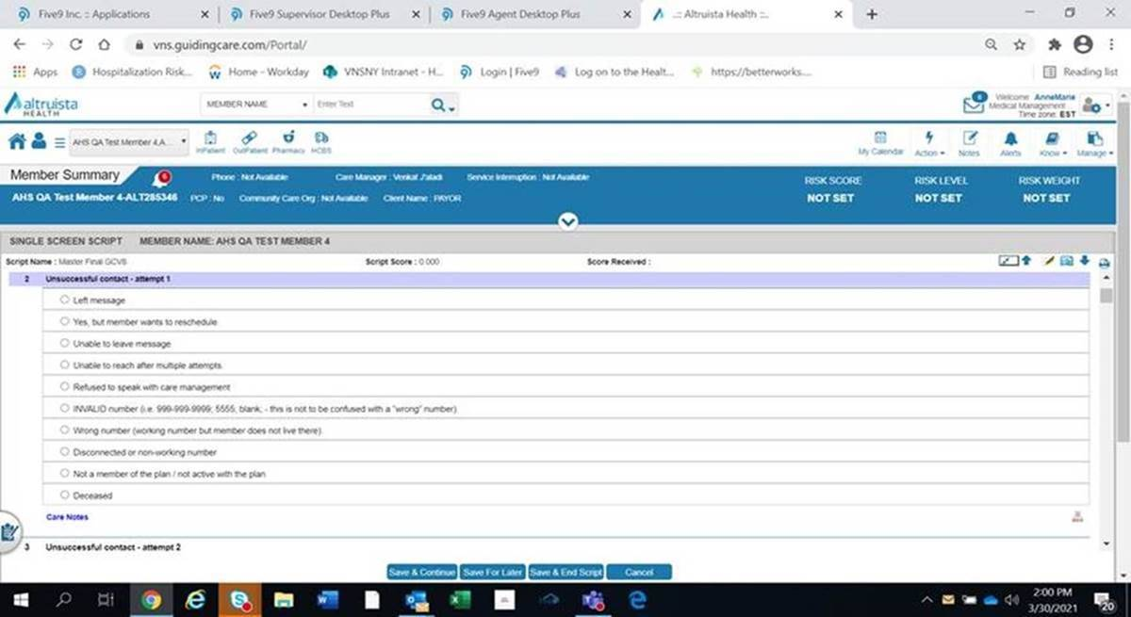

(ii)

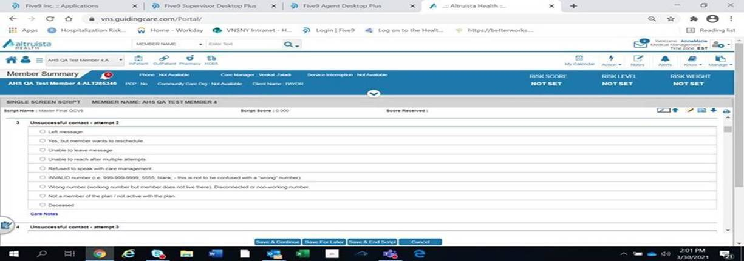

(iii)

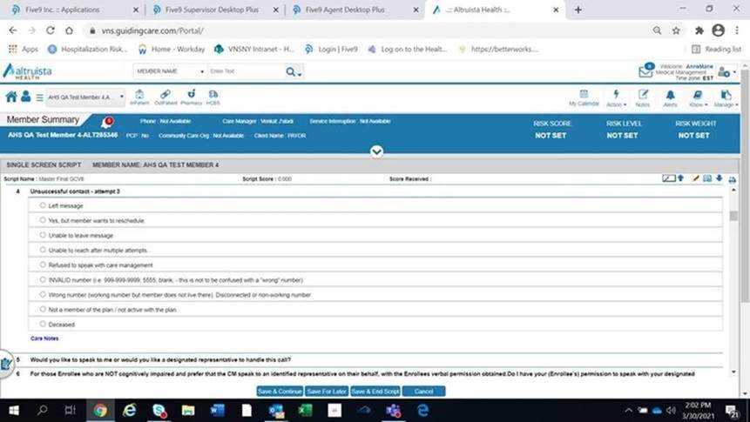

(iv) Master Script Response information:

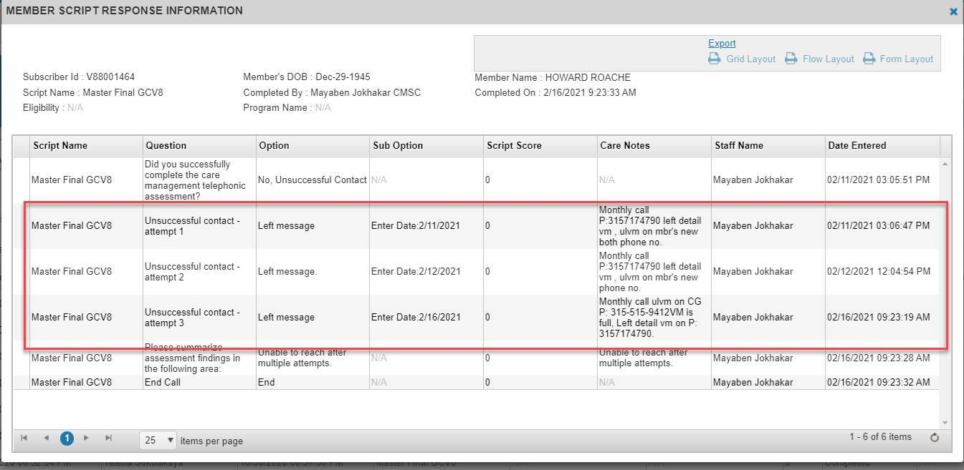

1. Sample daily PSP report:



1. Location of **PSCP Script Name** in Guiding Care, the status must be ‘Completed’, see below:

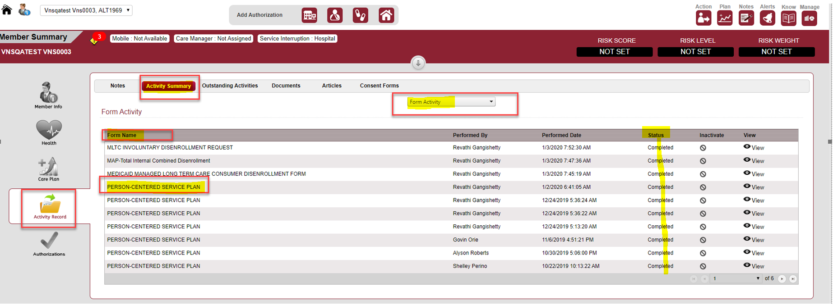

1. Location of the **Back-Up Care Plan** parameter in Guiding Care:

Health → Health Indicator→Parameter = Back-Up Care Plan, Value = TRUE.

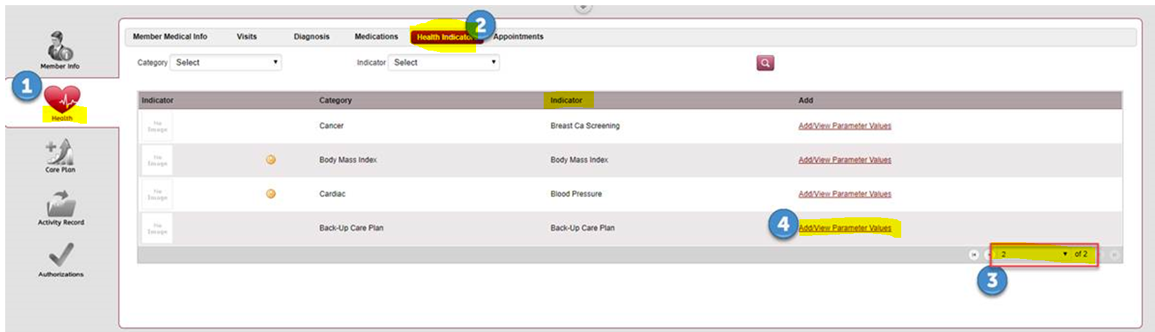

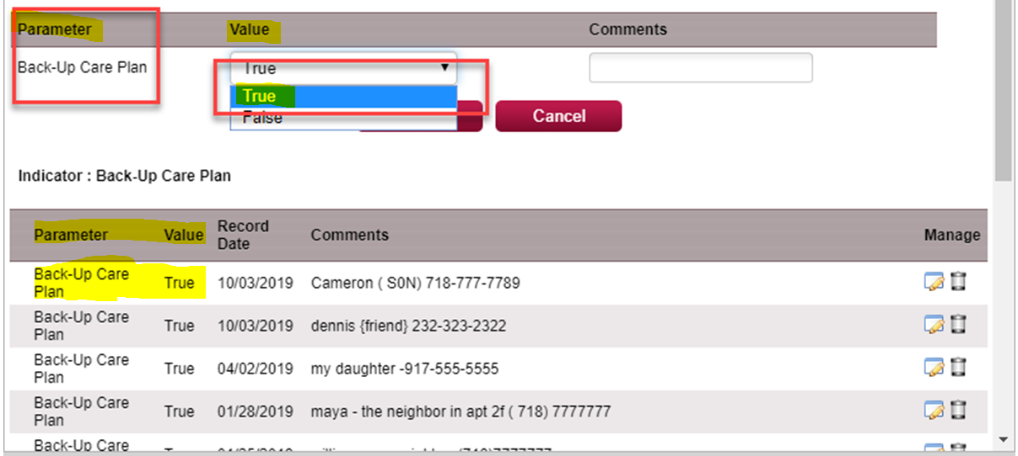

1. Location of identifying **Advanced Directives** completion in Guiding Care:

Care Plan → Advanced Directives → Addressed Date (must display a date within the current year).

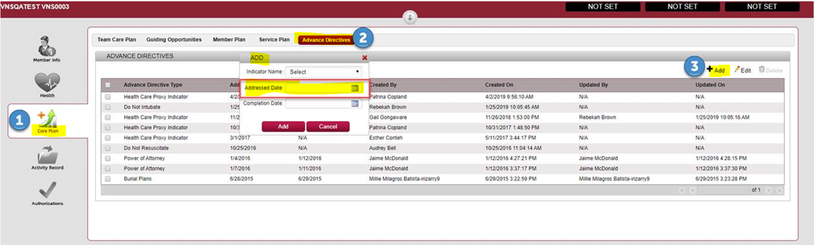

1. **MD Collaborator** details in Guiding Care:

**Member Info → Care Team→Care Giver → Care Giver Type = Secondary**

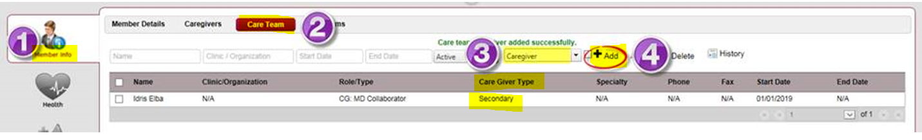

1. **MD Follow-up Appointment** details in Guiding Care:

**Health tab → Appointments → Status = Completed.**

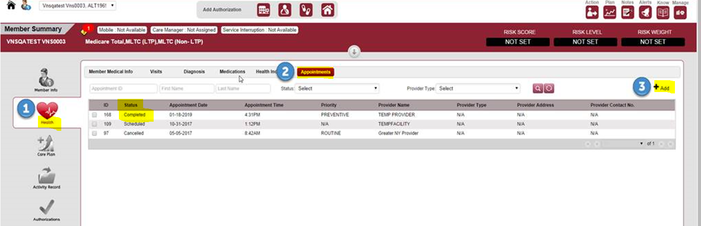

1. **HRA Completion** (on Enrollment and Annually) details in Guiding Care:

**Activity Record** →**Activity Summary**→**Activity Type = ‘Assessment’** →**Script run = ‘HRA Script’**→**Status =’Completed’**

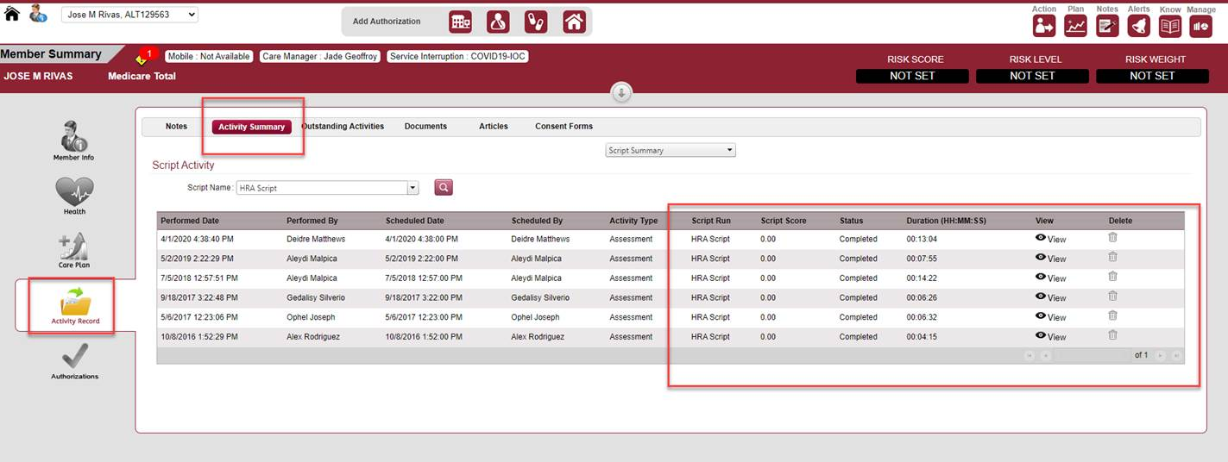

1. **Influenza Vaccine** details in Guiding Care:

**Health→Health Indicators→Parameter = Influenza Vaccine →Value =True→Record Date = between September through March**

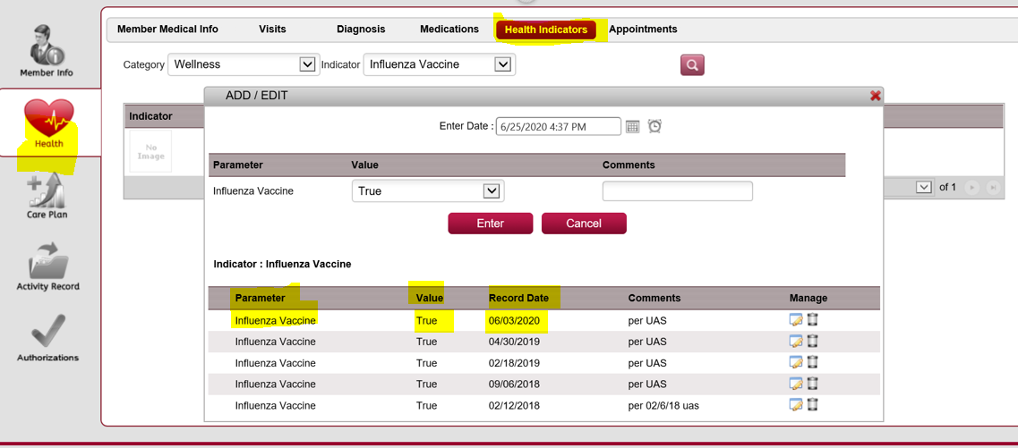

1. Welcome Call logic from Inna G.



Screenshot for completed ‘Welcome Call’ script in Guiding Care:

